**11. VM Image with Host OS**

**STEP 1:**

First install VMware workstation in your pc/laptop. Then open the VM software and click create a new virtual machine displayed on a home tab.

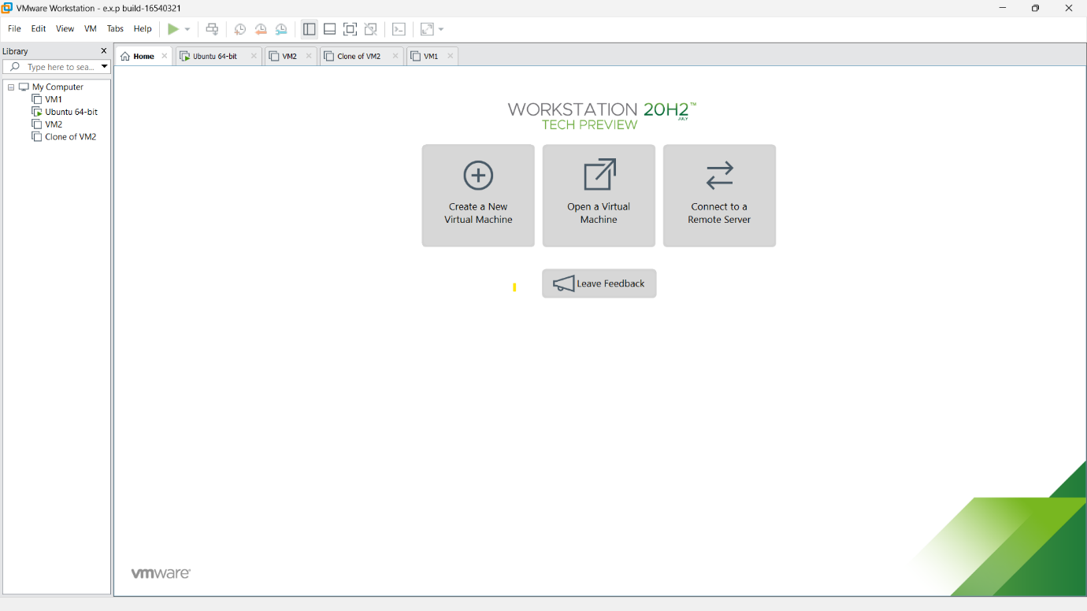

**STEP 2:**

Then below shown message will be displayed and click next.

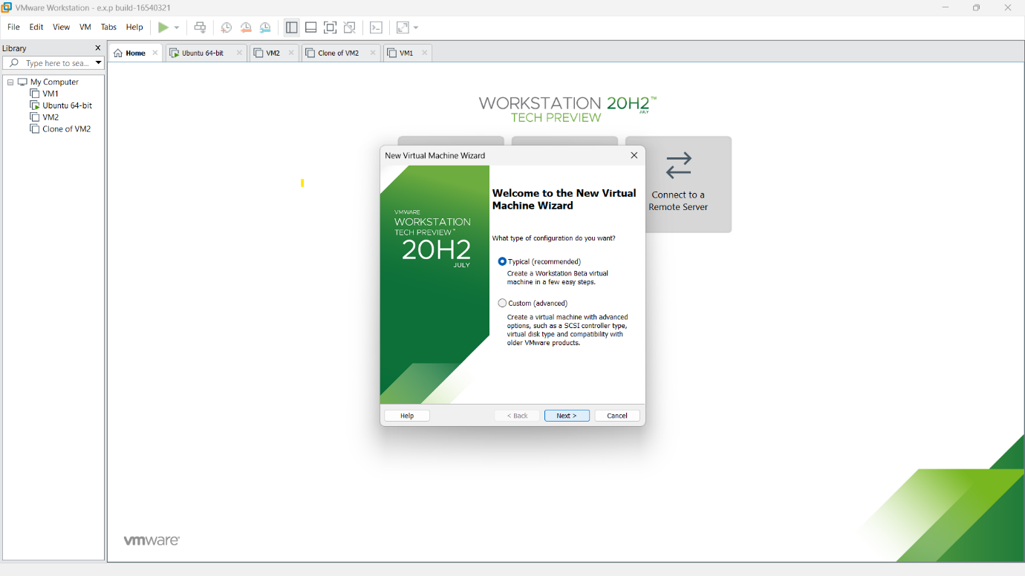

**STEP 3:**

Here ,we are going to Demonstrate virtualization by Installing Type -2 Hypervisor in the device, create and configure VM image with a Host Operating system (Either Windows/Linux).so choose the second option and browse the location of the OS which needs to be installed.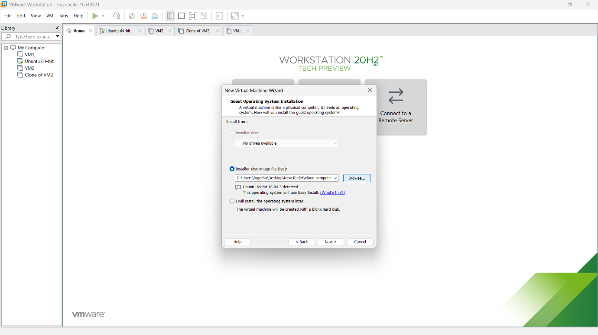

**STEP 4:**

Then provide an appropriate name and password for the OS which is going to be installed.

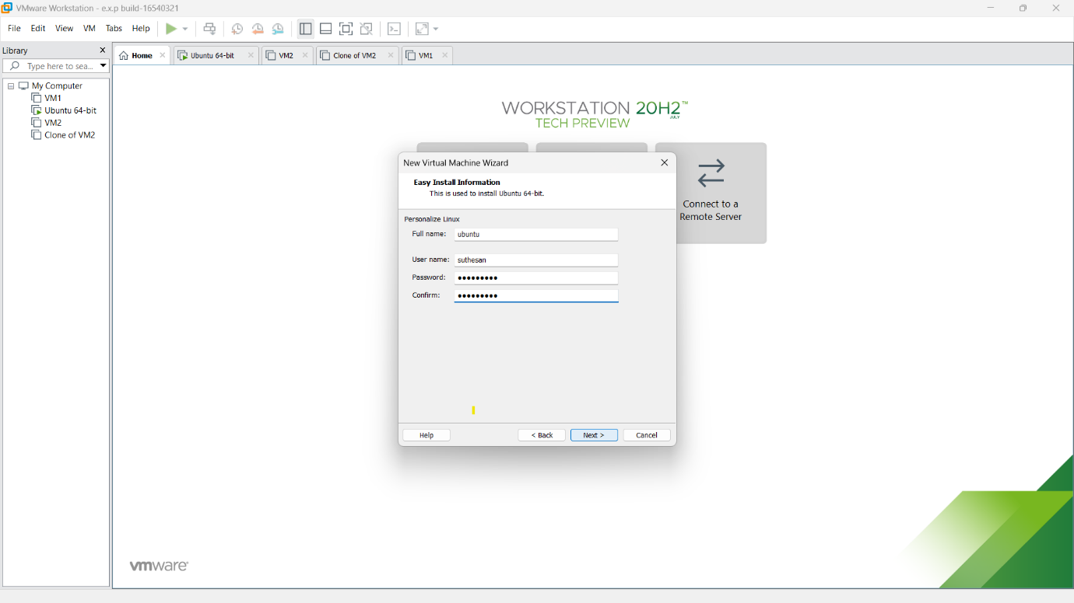

**STEP 5:**

Then provide the name for our application and browse the location in which needs to be saved.

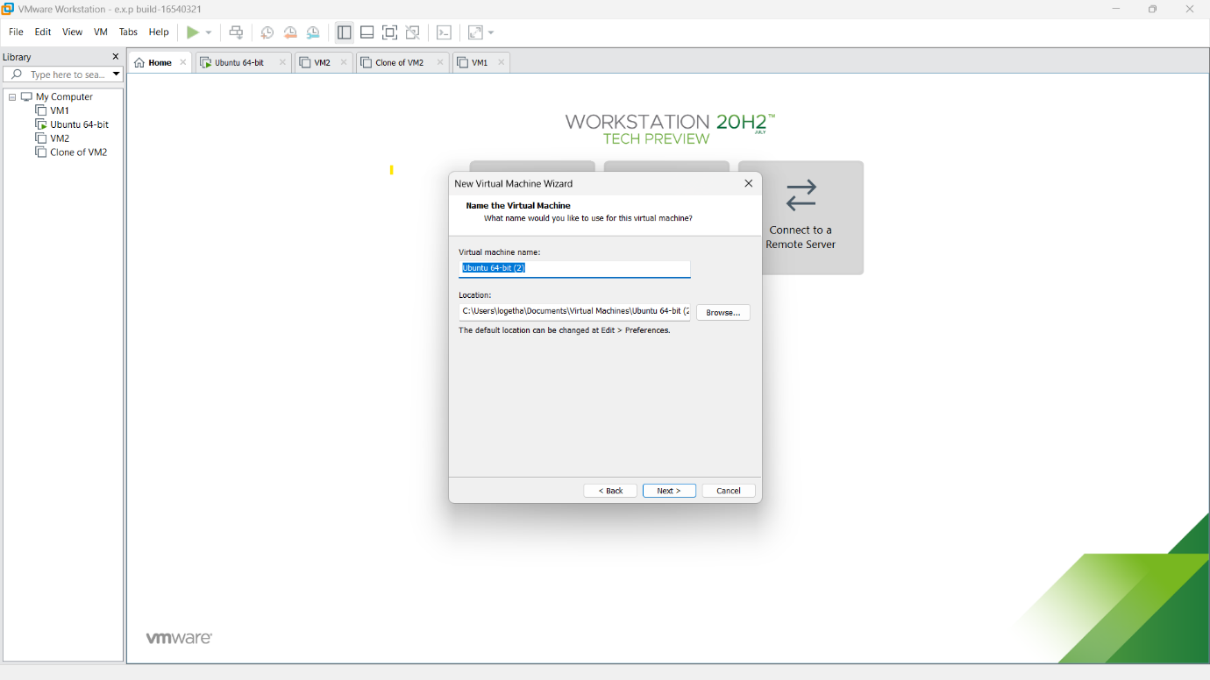

**STEP 6:**

Then a message will be displayed which consist of all the detail we mentioned. once verify it and click finish.

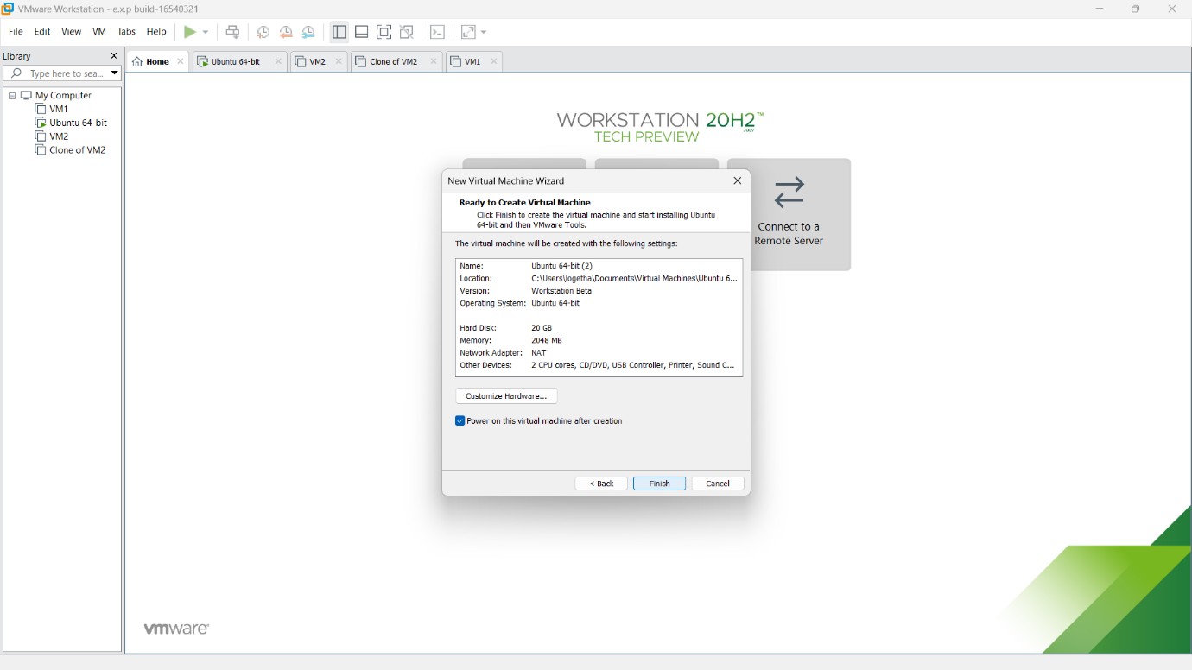

**STEP 7:**

Then our selected OS will be started to installation process.

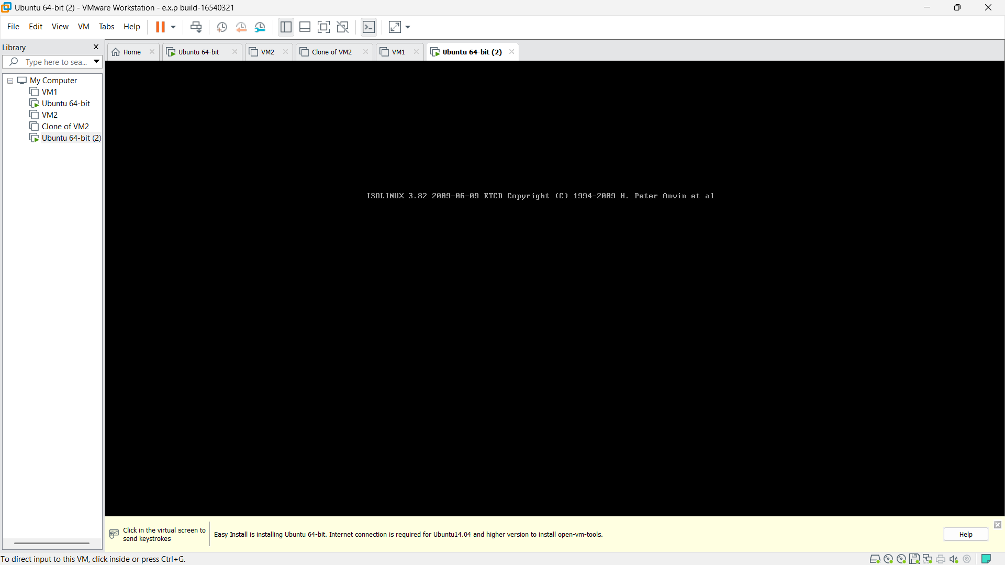

**STEP 8:**

It will take 20-30 min for first time.

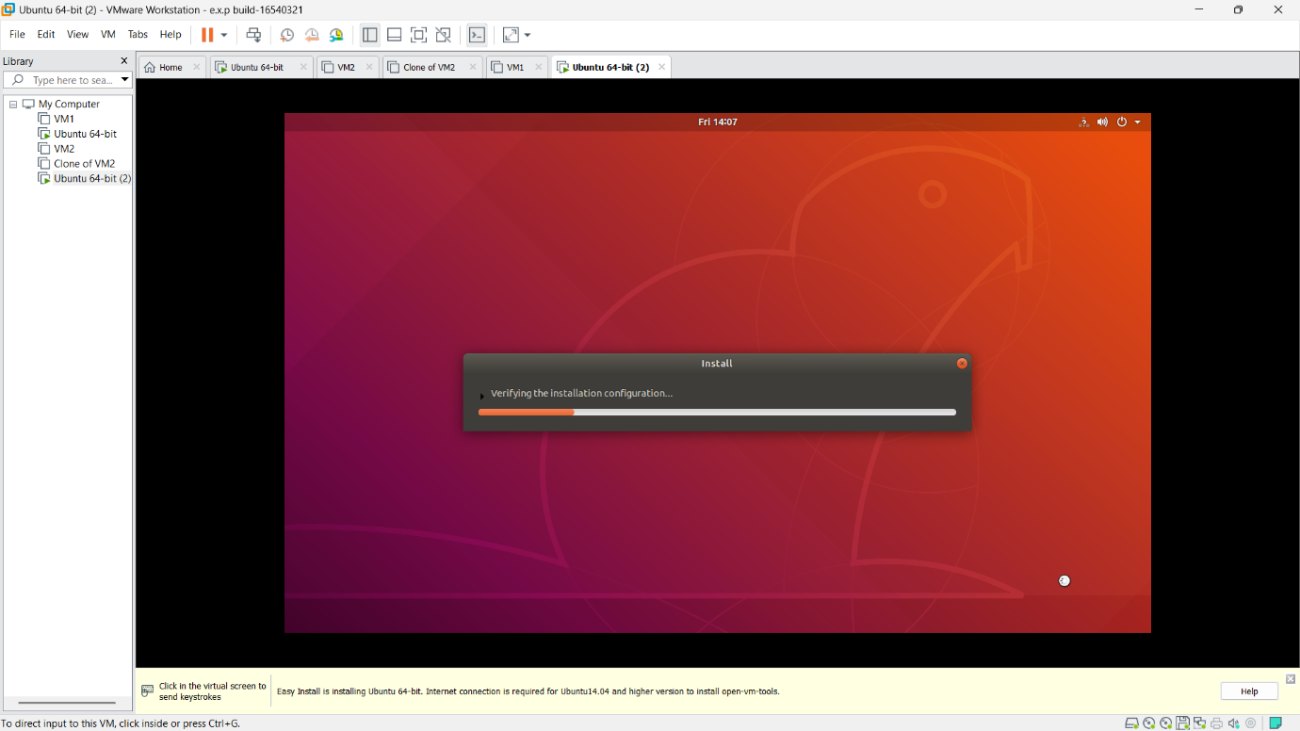

**STEP 9:**

After installation, provide essential password credentials and login, then the software is ready to use.

